**SHIMONI DEMONSTRATION SCHOOL- KIRA**

**MID TERM TWO EXAMINATIONS, 2023**

**BABY CLASS SOCIAL DEVELOPMENT**

**Name ____________________________________________________**

1. Colour a home .

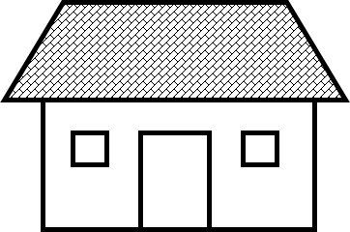

   

 v

1. Trace these people.

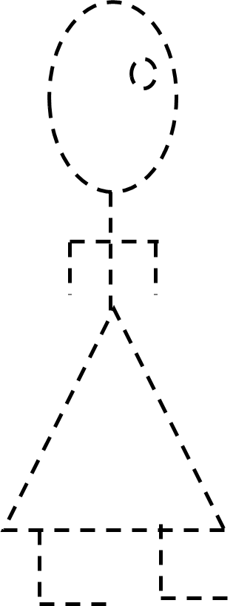 

1. Match the same people at school.

